**Round 2**

**Round 2 Experiment1: Length Contraction**

1. **Story Outline:**

**Length contraction** is the phenomenon that a moving object's length is measured to be shorter than its proper length, which is the length as measured in the object's own rest frame. This contraction (also known as **Lorentz contraction** or **Lorentz–FitzGerald contraction** after Hendrik Lorentz and George Francis FitzGerald) is usually only noticeable at a substantial fraction of the speed of light. Length contraction is only in the direction in which the body is travelling. For standard objects, this effect is negligible at everyday speeds, and can be ignored for all regular purposes, only becoming significant as the object approaches the speed of light relative to the observer.

1. **Story**
   1. **Set the visual stage discussion:**

**Construction of the set-up**

For better visualization, a simulator is provided. Time Dilation is always taught in a theoretical manner but there is always a need of some physical significance. Since performing this experiment in real life is not feasible because of cost issues, a simulation can always act as the best possible alternative. A space ship will be present that is set to move freely in the space. Two frames will be used in the set-up. One will be placed on the spaceship which measures length for the moving inertial frame and the other will be placed on Earth that measures length on rest frame.

* 1. **Set User Objectives & Goals:**
* Describe proper length.
* Calculate length contraction.
* Explain why we do not notice these effects at everyday scale.
  1. **Set the pathway activities:**

The set-up consists of a spaceship which is in space, two clocks kept on earth and space respectively.

1. Input fields to get length and Velocity of spaceship.
2. There would be a ‘Start’ button which will start the engine of ship and it will move.
3. You can take readings at any time by pressing “Record Observations”. Minimum 3 and maximum 10 observations are allowed.
4. “Graph” button allows you to plot a graph between dilated length and velocity of a moving frame of reference.
5. “Theoretical formula” gives the observed value of contracted length (non-proper length).

2.4 Set Challenges and Questions/Complexity/Variations in Questions:

1. When does length contraction affect an object?

* When it is not moving.
* Only at extremely slow speeds.
* Only when its moving at speeds near the speed of light
* At all times when it is moving

### Length contraction states that an object shrinks in what direction?

* The same as its movement
* All directions at once
* The direction perpendicular to its movement
* Towards the object's center of mass

**3. The second postulate of special relativity states what about the speed of light?**

* The speed of light in a vacuum is constant in any frame of reference
* The speed of light traveling through any medium is constant in any inertial frame of reference
* The speed of light in a vacuum is constant in any inertial frame of reference
* The speed of light in a vacuum can vary widely in any inertial frame of reference
  1. **Conclusion:**

Clarification of **Conclusion of Length Contraction** (Without **Lorentz** Transformations) ... "The **length** of an object is measured to be shorter when it is moving relative to the observer than when it is at rest."

* 1. **Equations/Formula:**

1. http://www.softschools.com/formulas/images/length_contraction_formula_1.png http://www.softschools.com/formulas/images/length_contraction_formula_2.png
2. Δl = the observed length, in the reference frame in which the object is moving (m)
3. Δl0 = the proper length, in the reference frame in which the object is at rest (m)
4. v = velocity (m/s)
5. c = speed of light (3.0 x 108 m/s)

Simulator screen will be displayed

Will ask least count of velocity for graph

Click on Submit button of least count

Press “Graph” to plot graph. Press “Theoretical Value” to get the formula based dilated time.

Select proper length (Kilometre, Meter, Centimetre, and Millimetre) from the list

Enter numeric value of Velocity from 0 to 1 (range)

Enter velocity of particle to set the particle moving with relativistic speed

from (0 to 1) times 3×108 sec

Wrong Answer

If a rod moves with velocity of light, what will be effect on its length?  
  
Length will be Contracted  
NO Change in the value of length

Question

**User will pass through the pitfall**

Correct Answer

Now user will click on record observation to record readings for the graph

Now a table will be formed having data sets of time and velocity on x and y axis

**User will pass through the pitfall**

If a rod moves with non-relativistic speed, its length would be contracted along the direction of its motion,

Refer to Einstein’s special theory of relativity

Question Hint

Now user will plot a graph from observation table (**Length Contacted Vs velocity**)

If user understands theory of Length Contracted, then user will be able to frame answers of given question

Click on Conclusion Button

1. Which of these statements are true for Lorentz transformation equation:-

**a)** For non-relativistic motion only  **b)** For relativistic motion only **c)** For both **d)** None Of these

2. Relativistic equations for Length Contraction hold true at**a)** speeds near that of light **b)** everyday low speeds **c)** all speeds **d)** only approximately



**Questions If answer wrong**

1. **Mind Map**

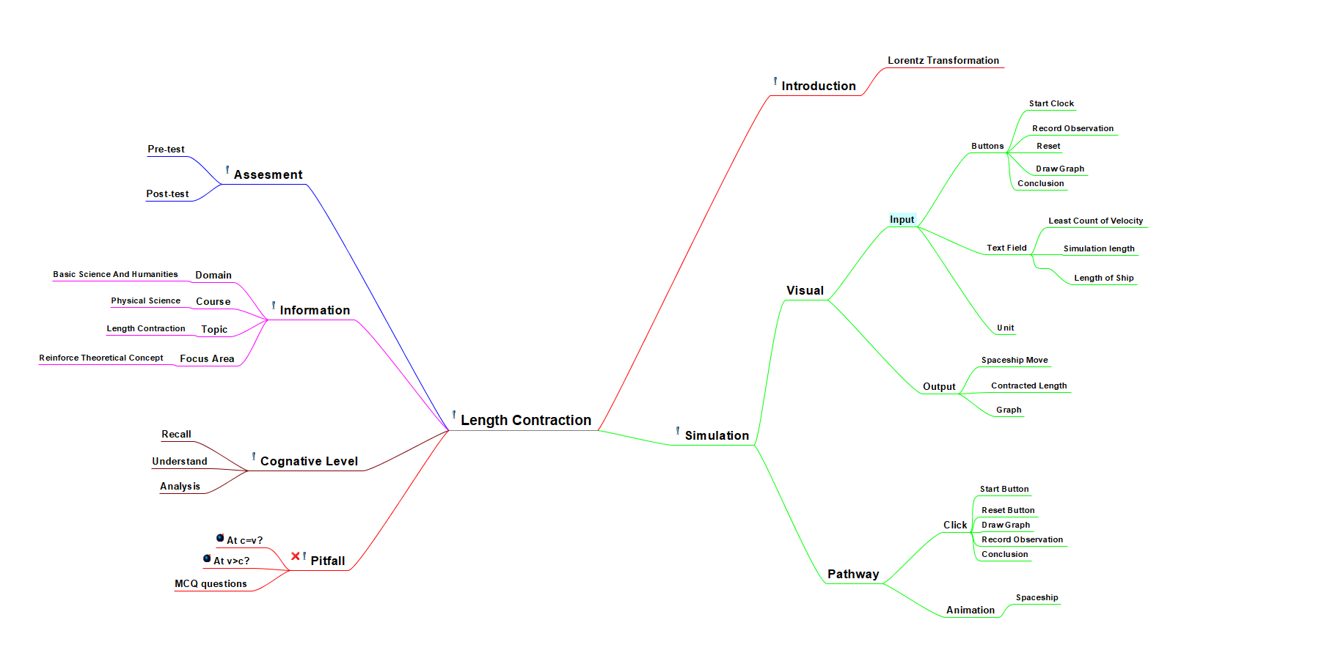

1. **Storyboard**





**OBSERVER A OBSERVER B**







